Two-Point Perspective
# Source: AI Source: Provided by: [Data Path: Persons Table -> ID Column: 1, Name_En Column: Motasem Essam] -> From: [ChatGPT] on [7/25/2026]
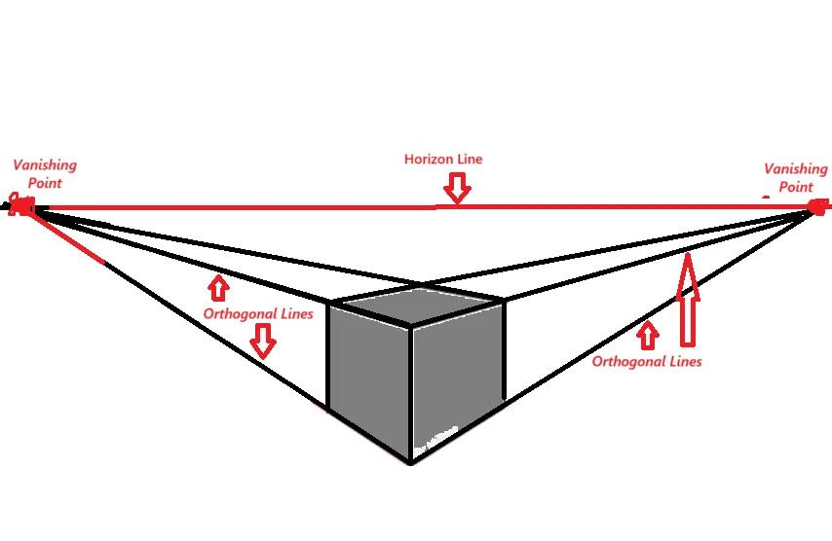
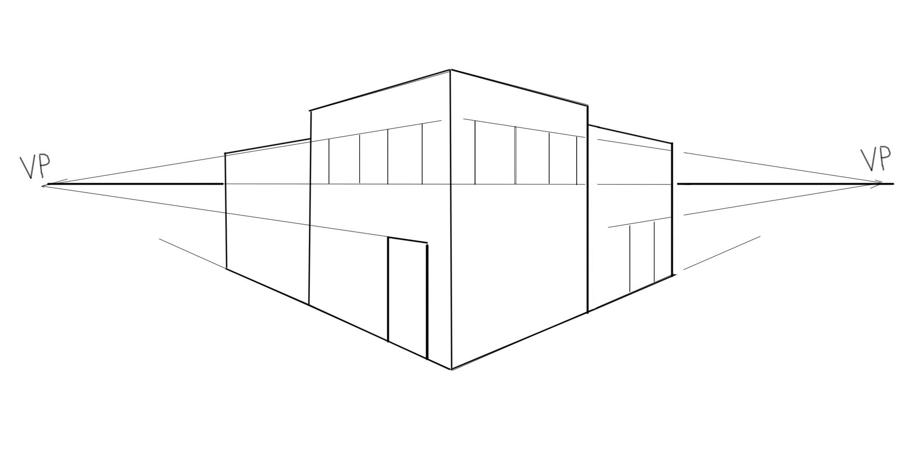
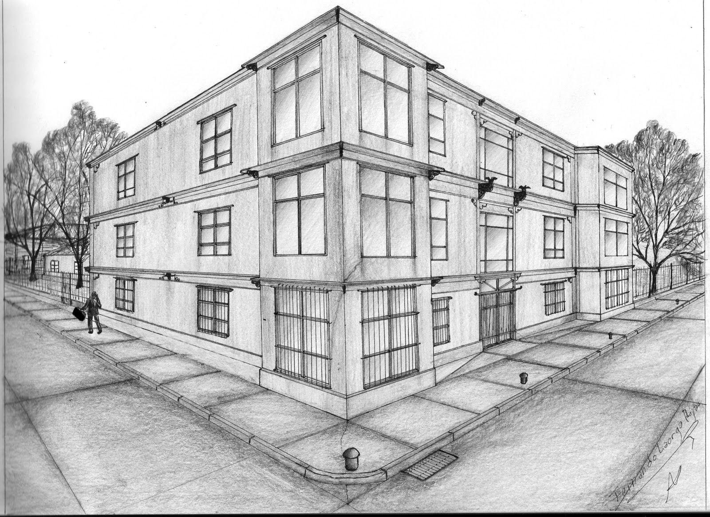
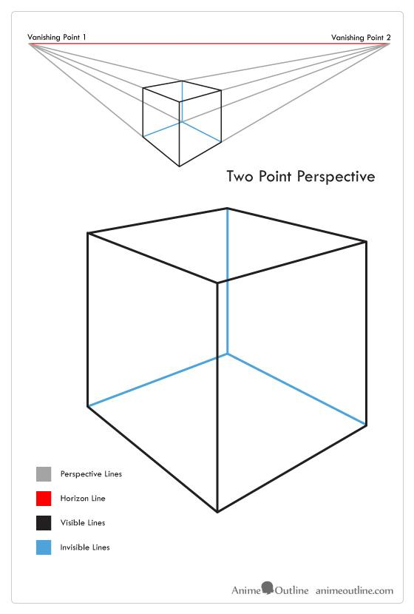
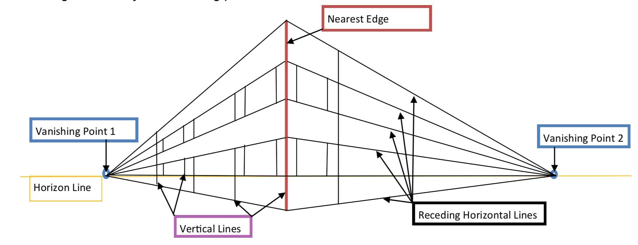
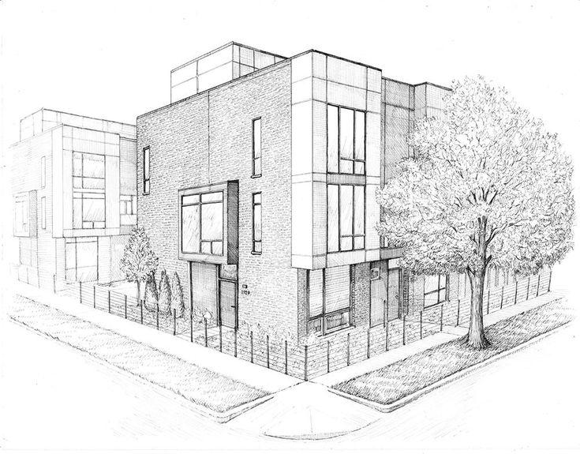

Definition
# Source: AI Source: Provided by: [Data Path: Persons Table -> ID Column: 1, Name_En Column: Motasem Essam] -> From: [ChatGPT] on [7/25/2026]
Two-Point Perspective is a type of perspective projection in which a three-dimensional object or scene is represented using two principal vanishing points.
It is commonly used when the viewer looks at an object from a corner, rather than directly at one of its faces.
The two principal horizontal directions of the object recede toward two different vanishing points.
$$\boxed{\text{Two-Point Perspective}=\text{Perspective Projection with Two Principal Vanishing Points}}$$

Purpose
# Source: AI Source: Provided by: [Data Path: Persons Table -> ID Column: 1, Name_En Column: Motasem Essam] -> From: [ChatGPT] on [7/25/2026]
Two-point perspective is used to:
- Represent 3D objects realistically.
- Show two sides of an object simultaneously.
- Represent buildings viewed from a corner.
- Create architectural perspectives.
- Represent boxes and rectangular solids.
- Show depth in two horizontal directions.
- Create realistic illustrations.
- Visualize buildings, streets, and urban environments.

Basic Configuration
# Source: AI Source: Provided by: [Data Path: Persons Table -> ID Column: 1, Name_En Column: Motasem Essam] -> From: [ChatGPT] on [7/25/2026]
The main elements are:
- Projection Center
- Projection Plane
- Horizon Line
- Left Vanishing Point
- Right Vanishing Point
- Object
- Receding Lines
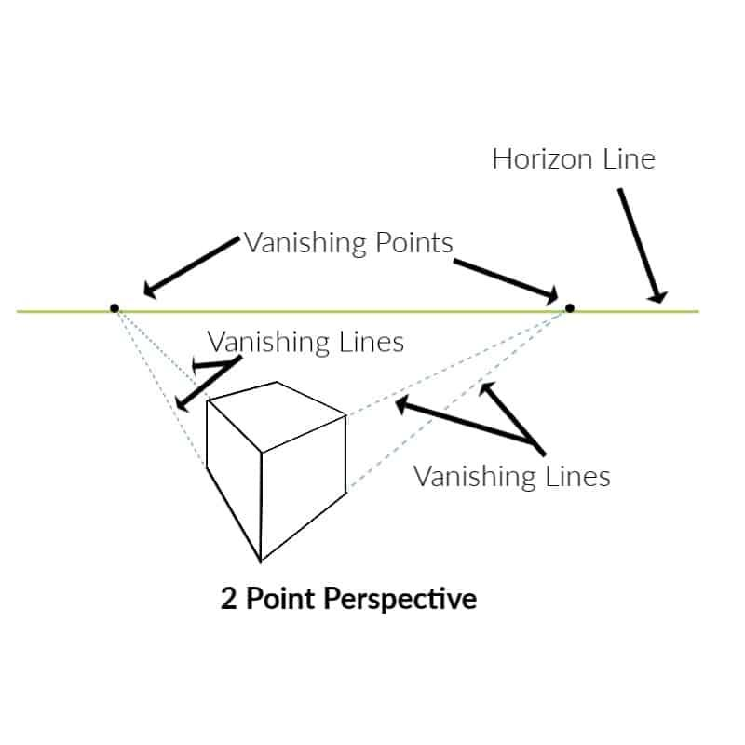
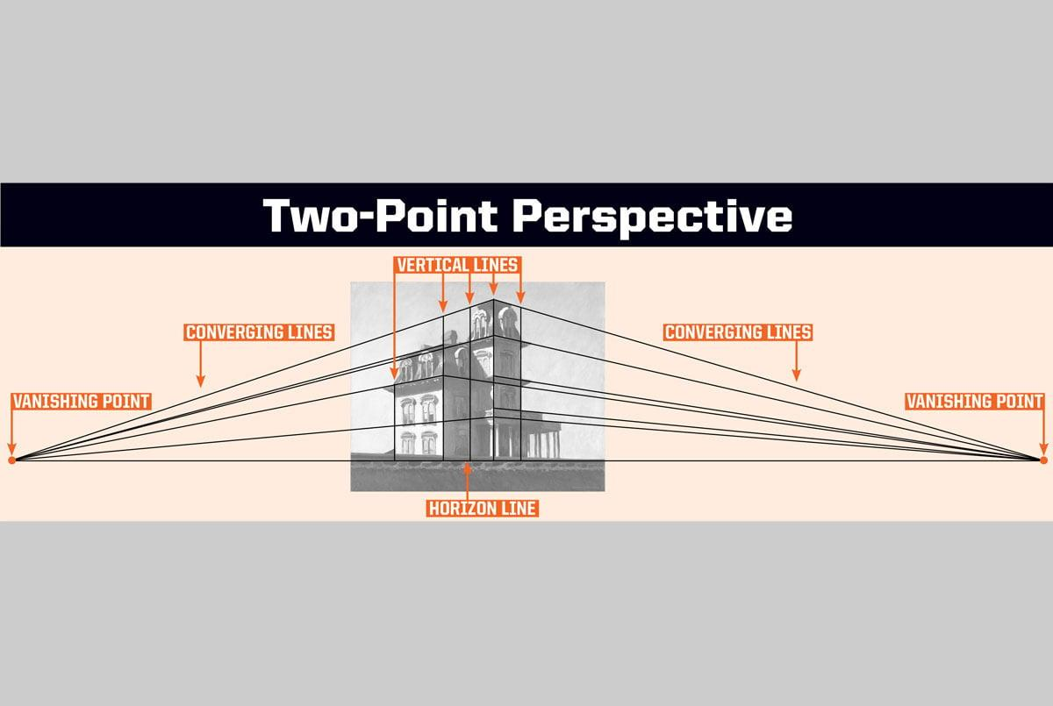
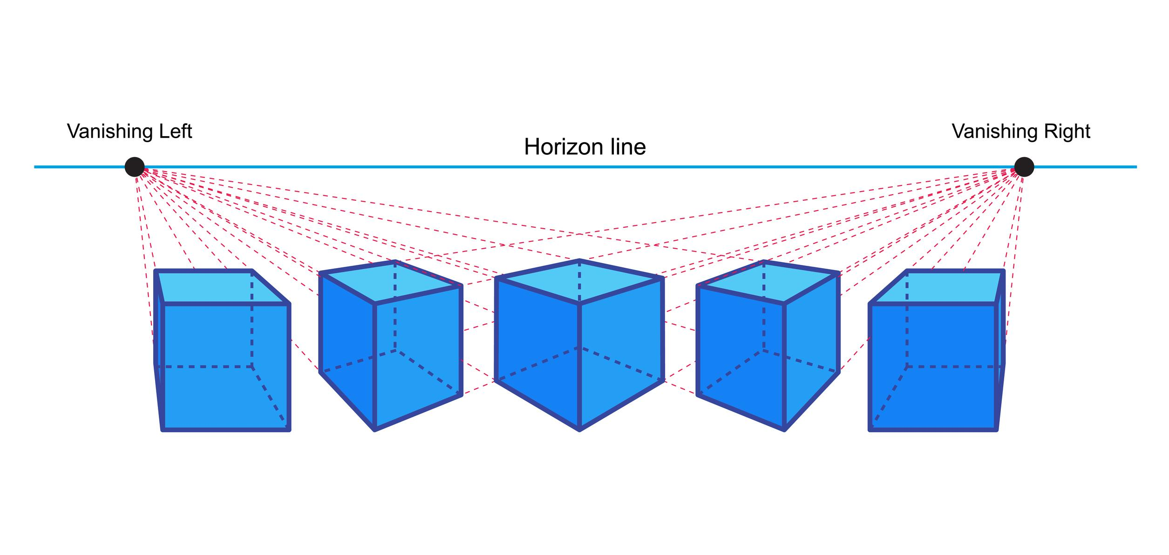
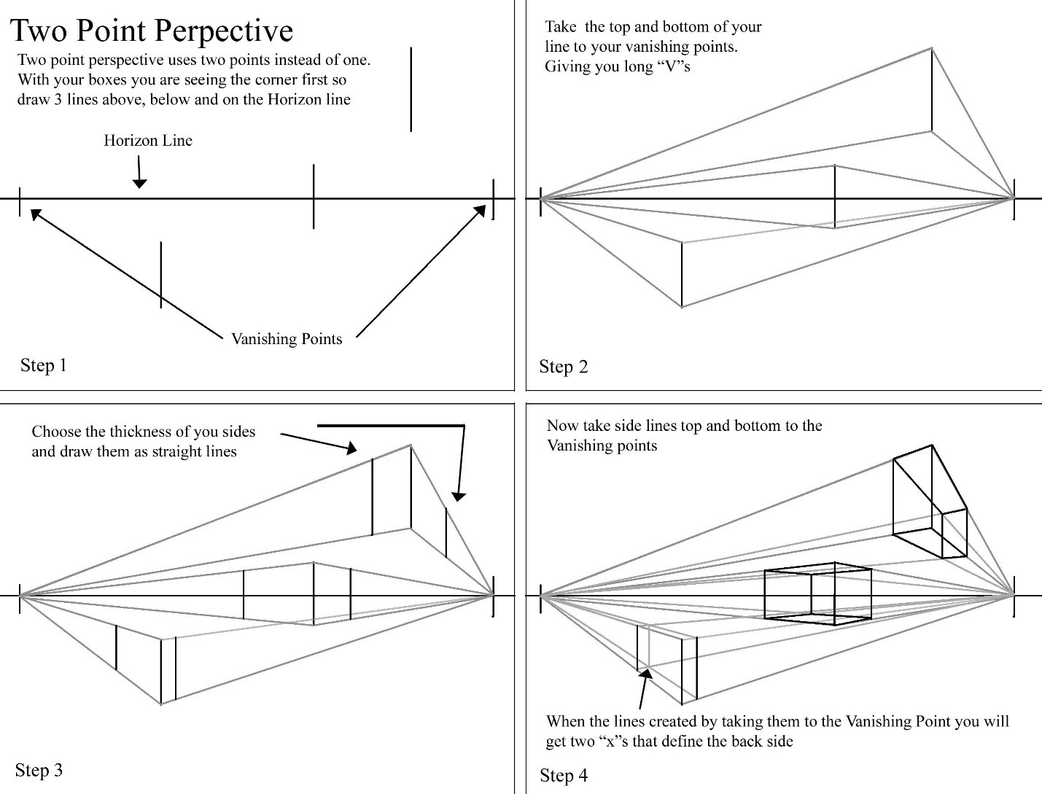
The two vanishing points can be represented as:
$$V_{L}$$
and:
$$V_{R}$$
Both lie on the horizon line:
$$\boxed{V_{L},V_{R}∈HL}$$

Fundamental Elements

1. Projection Center
# Source: AI Source: Provided by: [Data Path: Persons Table -> ID Column: 1, Name_En Column: Motasem Essam] -> From: [ChatGPT] on [7/25/2026]
The viewpoint or center of projection is represented by:
$$O$$
Perspective projection lines originate from this center.

2. Projection Plane
# Source: AI Source: Provided by: [Data Path: Persons Table -> ID Column: 1, Name_En Column: Motasem Essam] -> From: [ChatGPT] on [7/25/2026]
The 2D plane onto which the 3D scene is projected:
$$Π$$

3. Horizon Line
# Source: AI Source: Provided by: [Data Path: Persons Table -> ID Column: 1, Name_En Column: Motasem Essam] -> From: [ChatGPT] on [7/25/2026]
The horizon line represents the viewer's eye level:
$$HL$$
Both principal vanishing points lie on it.

4. Left Vanishing Point
# Source: AI Source: Provided by: [Data Path: Persons Table -> ID Column: 1, Name_En Column: Motasem Essam] -> From: [ChatGPT] on [7/25/2026]
The first principal vanishing point:
$$V_{L}$$
Lines receding in one horizontal direction converge toward it.

5. Right Vanishing Point
# Source: AI Source: Provided by: [Data Path: Persons Table -> ID Column: 1, Name_En Column: Motasem Essam] -> From: [ChatGPT] on [7/25/2026]
The second principal vanishing point:
$$V_{R}$$
Lines receding in the opposite horizontal direction converge toward it.

6. Vertical Direction
# Source: AI Source: Provided by: [Data Path: Persons Table -> ID Column: 1, Name_En Column: Motasem Essam] -> From: [ChatGPT] on [7/25/2026]
In the standard two-point perspective setup, vertical edges can remain vertical because the vertical direction is parallel to the picture plane.
For example:
$$AB∥CD$$
may remain represented as parallel vertical lines.

Main Characteristics
# Source: AI Source: Provided by: [Data Path: Persons Table -> ID Column: 1, Name_En Column: Motasem Essam] -> From: [ChatGPT] on [7/25/2026]
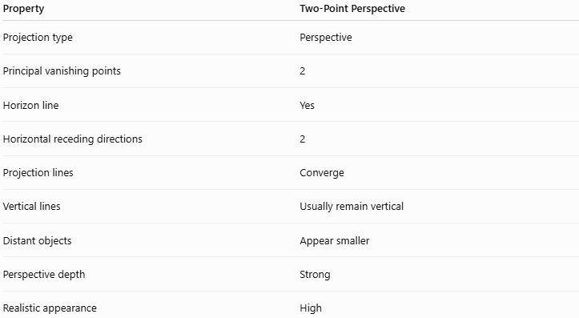
Property | Two-Point Perspective
Projection type | Perspective
Principal vanishing points | 2
Horizon line | Yes
Horizontal receding directions | 2
Projection lines | Converge
Vertical lines | Usually remain vertical
Distant objects | Appear smaller
Perspective depth | Strong
Realistic appearance | High

Two Vanishing Points
# Source: AI Source: Provided by: [Data Path: Persons Table -> ID Column: 1, Name_En Column: Motasem Essam] -> From: [ChatGPT] on [7/25/2026]
The defining feature is the presence of two principal vanishing points:
$$\boxed{V_{L}≠V_{R}}$$
A set of parallel lines in one horizontal direction converges toward:
$$V_{L}$$
while another set of parallel lines in a different horizontal direction converges toward:
$$V_{R}$$
Thus:
$$\boxed{\text{Direction 1}→V_{L}} \\ \boxed{\text{Direction 2}→V_{R}}$$
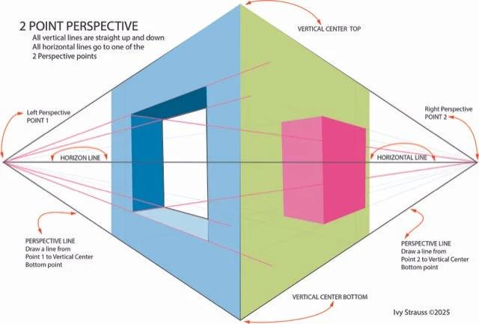
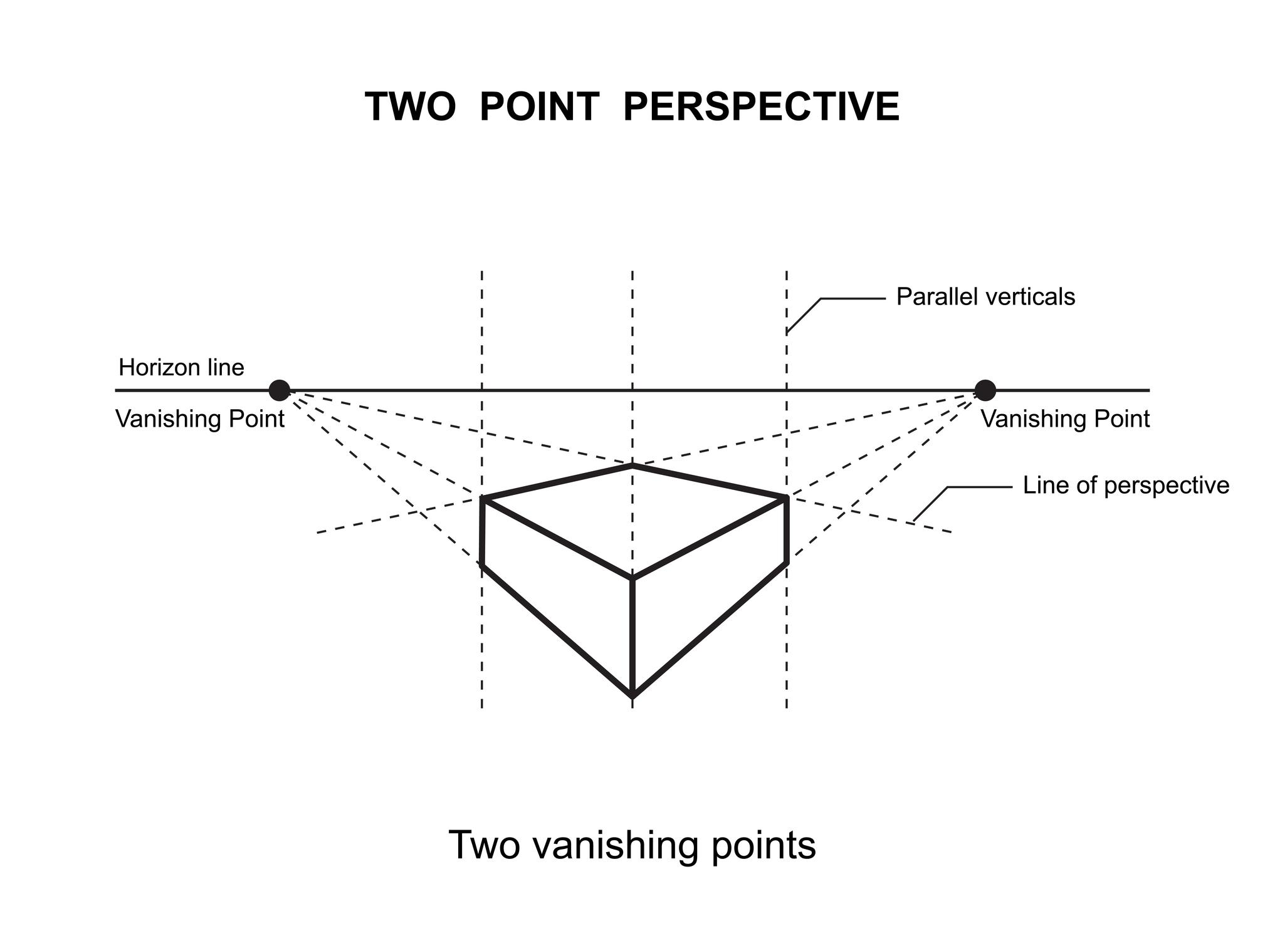
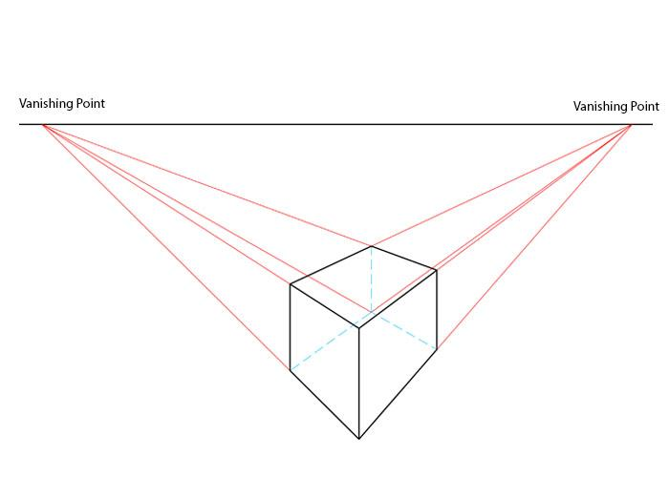

Two-Point Perspective of a Cube
# Source: AI Source: Provided by: [Data Path: Persons Table -> ID Column: 1, Name_En Column: Motasem Essam] -> From: [ChatGPT] on [7/25/2026]
A cube is a classic example.
Instead of looking directly at one face, imagine rotating the cube so that you see two faces.
The horizontal edges of one face converge toward:
$$V_{L}$$
while the horizontal edges of the other face converge toward:
$$V_{R}$$
The vertical edges can remain vertical.
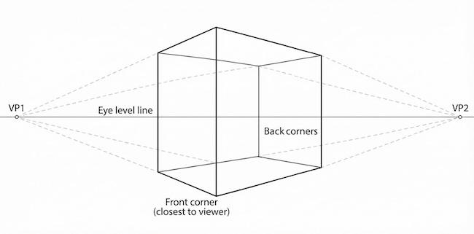

Mathematical Representation
# Source: AI Source: Provided by: [Data Path: Persons Table -> ID Column: 1, Name_En Column: Motasem Essam] -> From: [ChatGPT] on [7/25/2026]
The general perspective projection of a point can be written as:
$$P^{'}=O+t\left(P-O\right)$$
where:
- $O$= projection center
- $P$= original 3D point
- $P^{'}$= projected point
- $t$= scalar determined by the projection plane
Two-point perspective results when two principal families of horizontal parallel lines have different vanishing points.

Vanishing Point Relationship
# Source: AI Source: Provided by: [Data Path: Persons Table -> ID Column: 1, Name_En Column: Motasem Essam] -> From: [ChatGPT] on [7/25/2026]
Suppose a set of parallel 3D lines has direction:
$$d_{1}$$
Its projected lines converge toward:
$$V_{L}$$
Another set has direction:
$$d_{2}$$
and converges toward:
$$V_{R}$$
Therefore:
$$\boxed{d_{1}→V_{L}} \\ \boxed{d_{2}→V_{R}}$$
The two directions correspond to the two visible sides of the object.

Example 1: Building
# Source: AI Source: Provided by: [Data Path: Persons Table -> ID Column: 1, Name_En Column: Motasem Essam] -> From: [ChatGPT] on [7/25/2026]
Consider a rectangular building viewed from one of its corners.
The edges extending toward the left side converge toward:
$$V_{L}$$
and edges extending toward the right side converge toward:
$$V_{R}$$
The vertical edges remain approximately vertical.
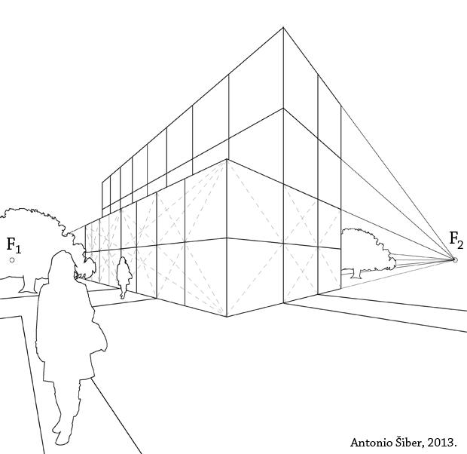
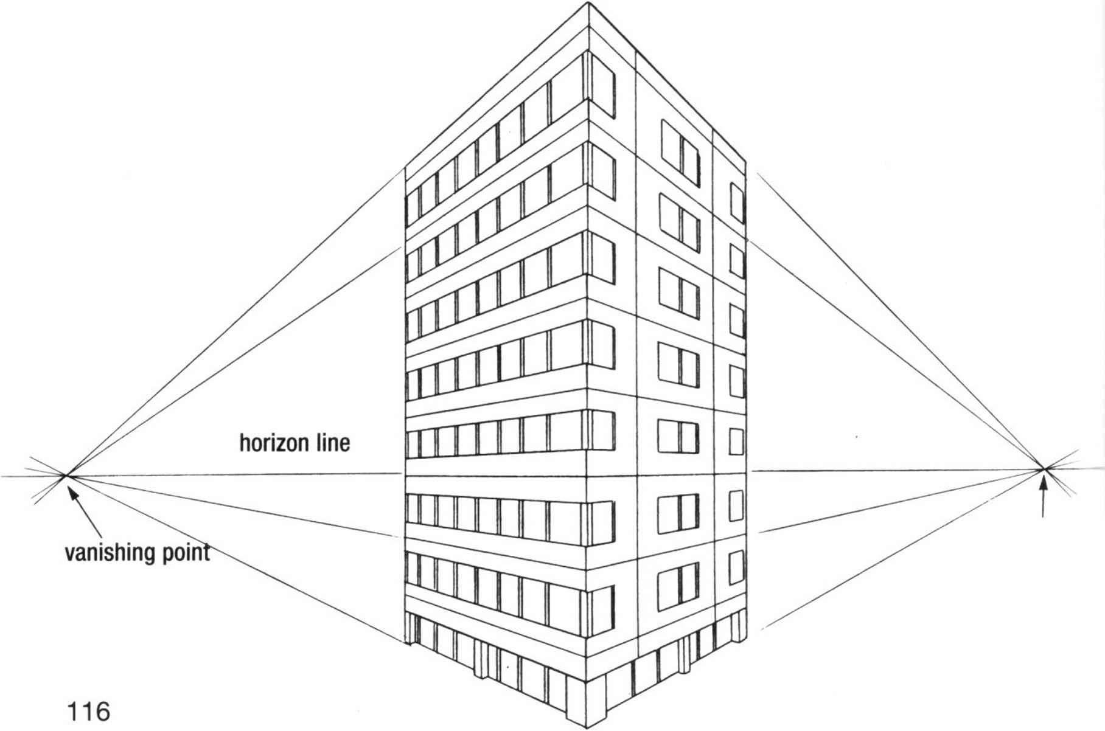
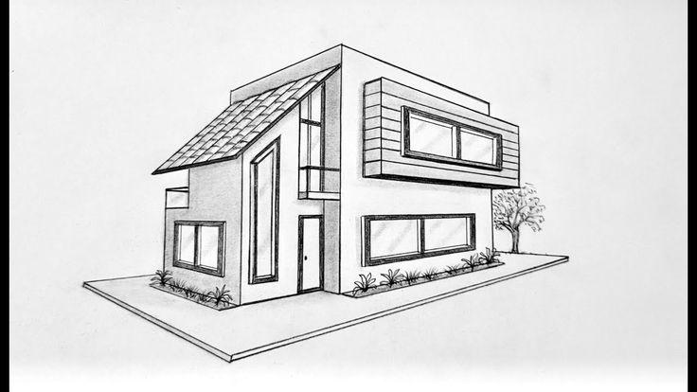
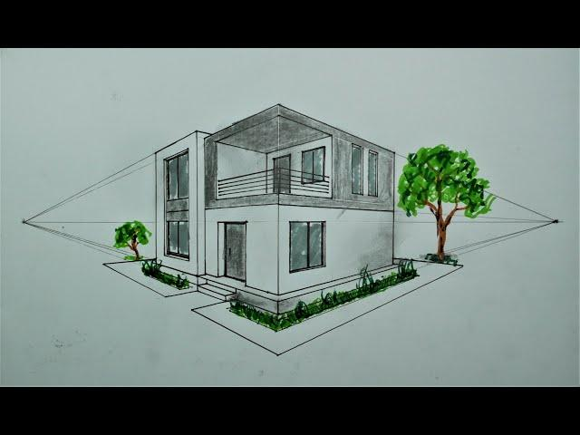
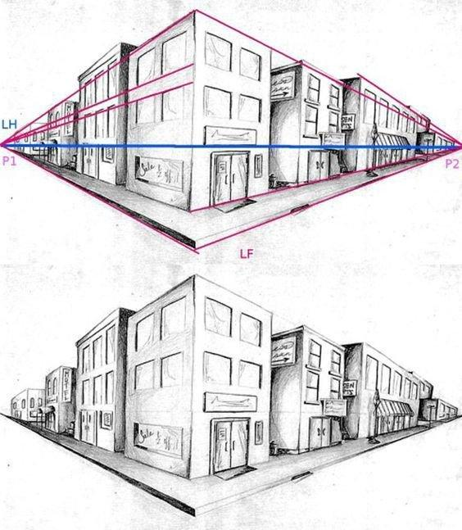
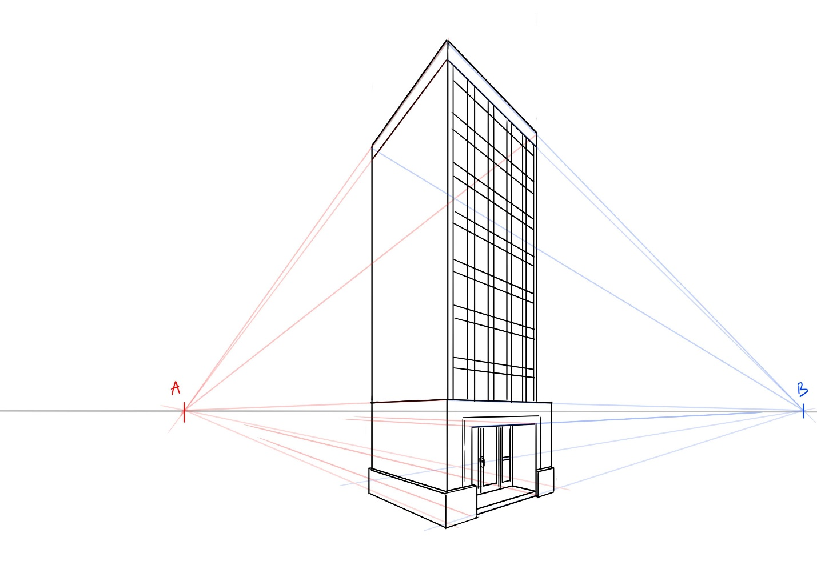
This makes the building appear three-dimensional and realistic.

Example 2: Box
# Source: AI Source: Provided by: [Data Path: Persons Table -> ID Column: 1, Name_En Column: Motasem Essam] -> From: [ChatGPT] on [7/25/2026]
Suppose a rectangular box has:
$$W=8 \\ H=5 \\ D=6$$
When viewed from a corner, the left-facing and right-facing horizontal edges recede toward different vanishing points.
Unlike Cavalier or Cabinet projection, there is no fixed depth scale such as $\frac{1}{2}$.
Instead, apparent size depends on the object's position relative to the viewer.

Example 3: Street Corner
# Source: AI Source: Provided by: [Data Path: Persons Table -> ID Column: 1, Name_En Column: Motasem Essam] -> From: [ChatGPT] on [7/25/2026]
Imagine looking down a street from a corner.
Buildings on one side have horizontal lines converging toward one vanishing point:
$$V_{L}$$
while lines associated with the other direction converge toward:
$$V_{R}$$
This creates a realistic urban perspective.

Horizon Line
# Source: AI Source: Provided by: [Data Path: Persons Table -> ID Column: 1, Name_En Column: Motasem Essam] -> From: [ChatGPT] on [7/25/2026]
The two vanishing points lie on the same horizon line:
$$\boxed{V_{L},V_{R}∈HL}$$
The distance between the vanishing points affects the apparent perspective.
If the vanishing points are very far apart, the perspective can appear relatively subtle.
If they are closer to the object, the perspective can appear stronger.
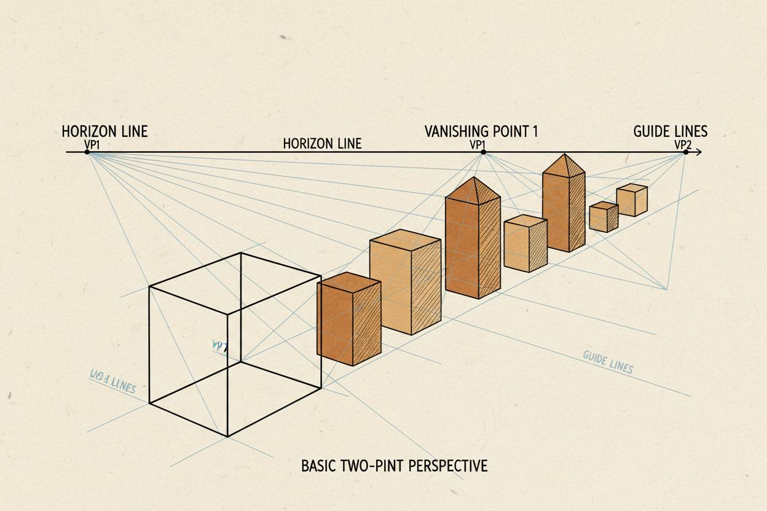
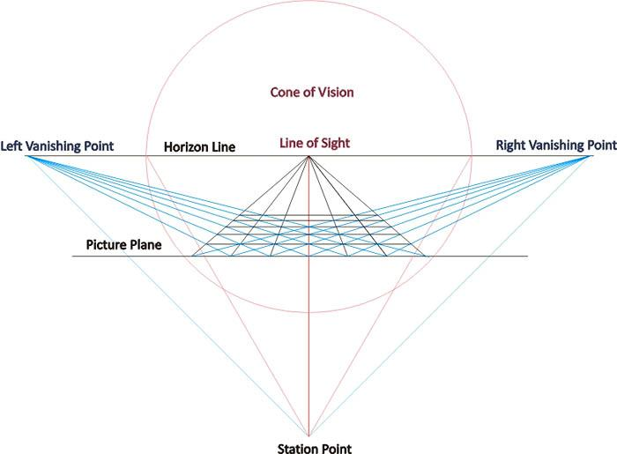
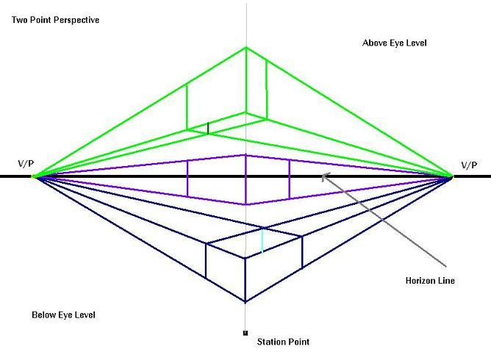
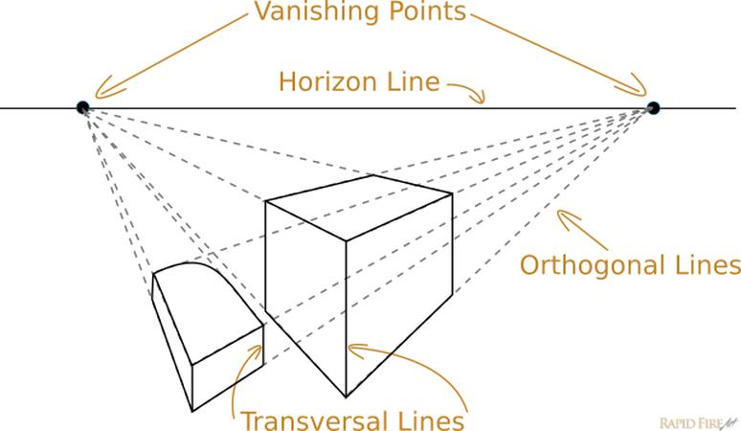
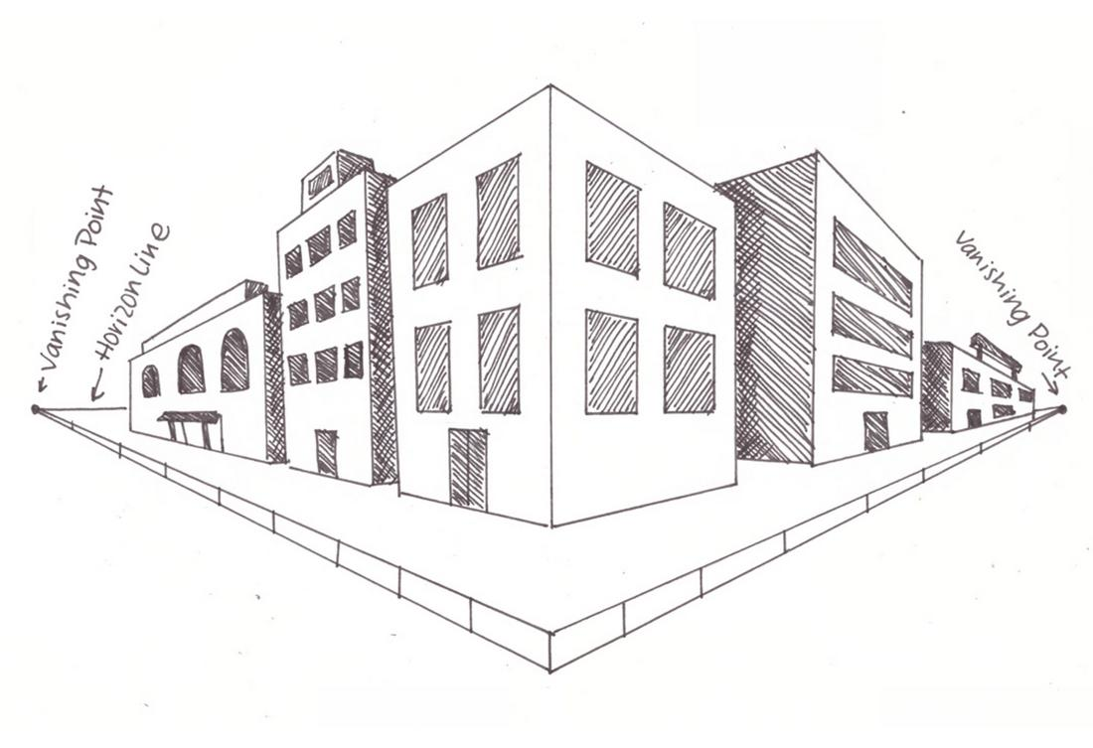

How to Construct Two-Point Perspective
# Source: AI Source: Provided by: [Data Path: Persons Table -> ID Column: 1, Name_En Column: Motasem Essam] -> From: [ChatGPT] on [7/25/2026]
Step 1 — Draw the Horizon Line
Draw the eye-level line:
$$HL$$
Step 2 — Choose Two Vanishing Points
Place:
$$V_{L}$$
on the left and:
$$V_{R}$$
on the right.
Both should lie on the horizon line.
Step 3 — Draw the Front Corner
Draw a vertical line representing the nearest corner of the object.
Step 4 — Connect the Top and Bottom Points
Connect the endpoints of the vertical line to both vanishing points.
$$\text{Top}→V_{L}, \text{Top}→V_{R} \\ \text{Bottom}→V_{L}, \text{Bottom}→V_{R}$$
Step 5 — Determine the Side Boundaries
Choose where the sides of the object end.
Step 6 — Draw the Vertical Edges
Connect the corresponding points with vertical lines.
The resulting shape represents the object in two-point perspective.
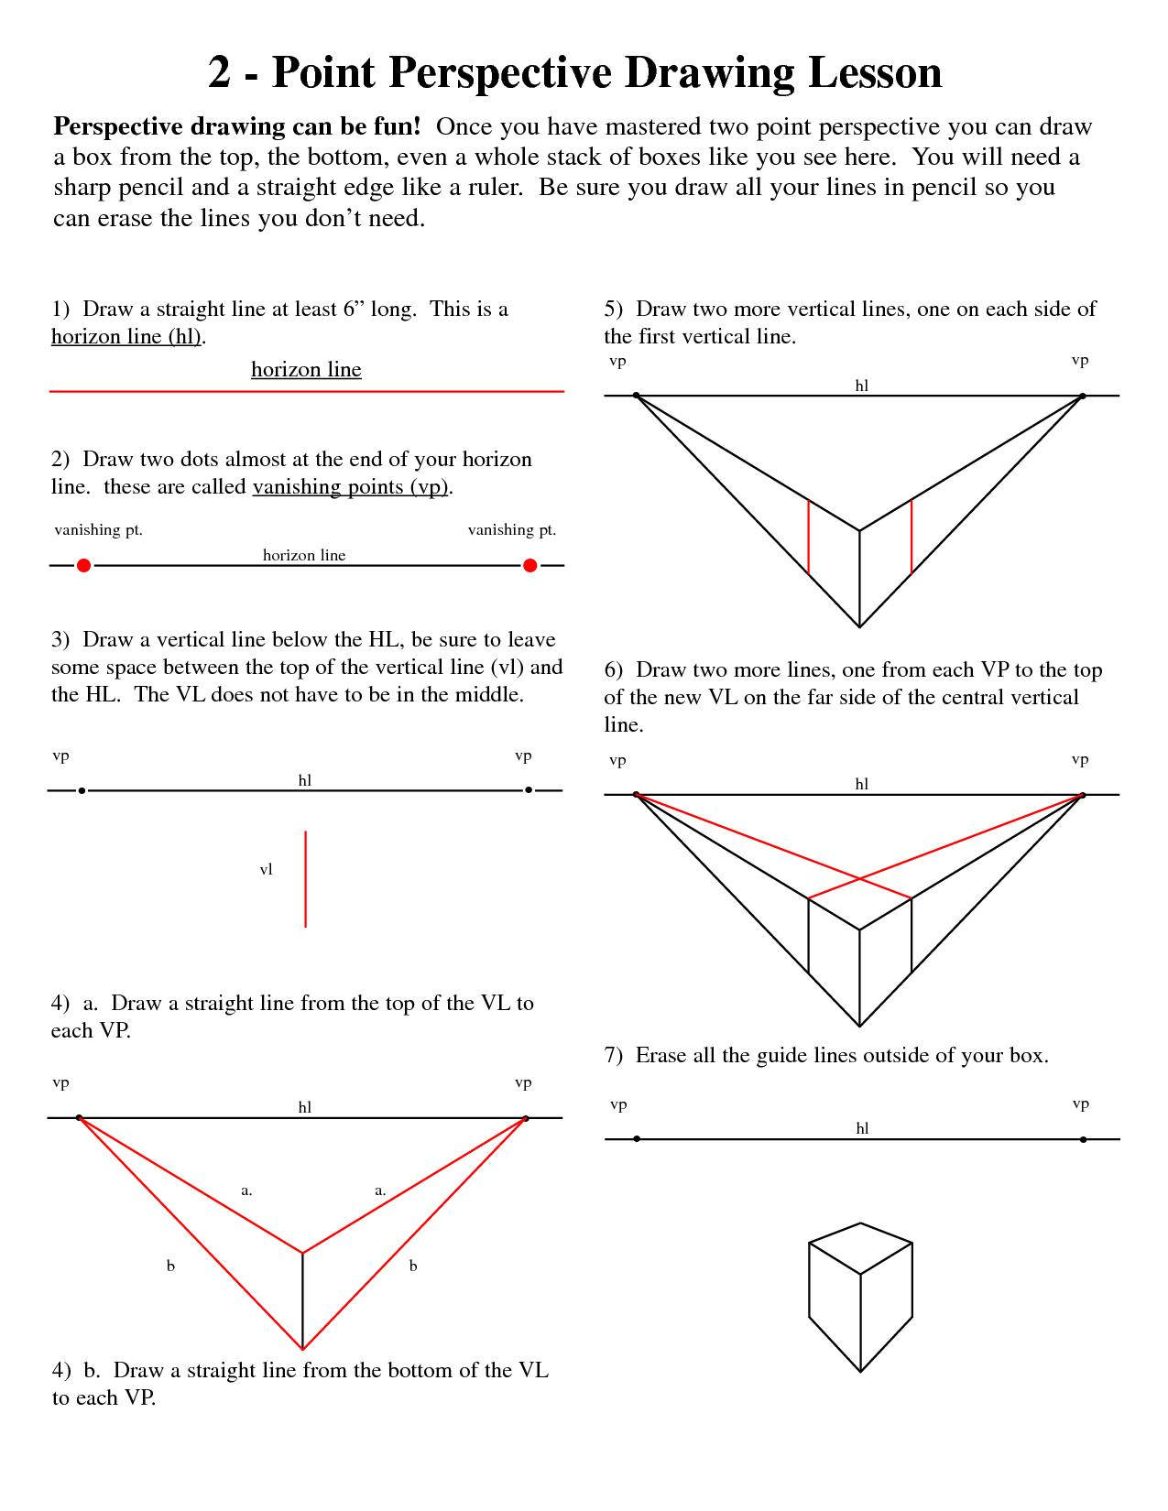
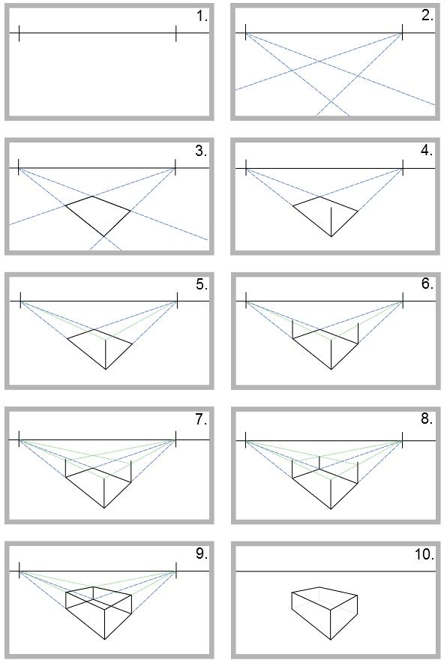
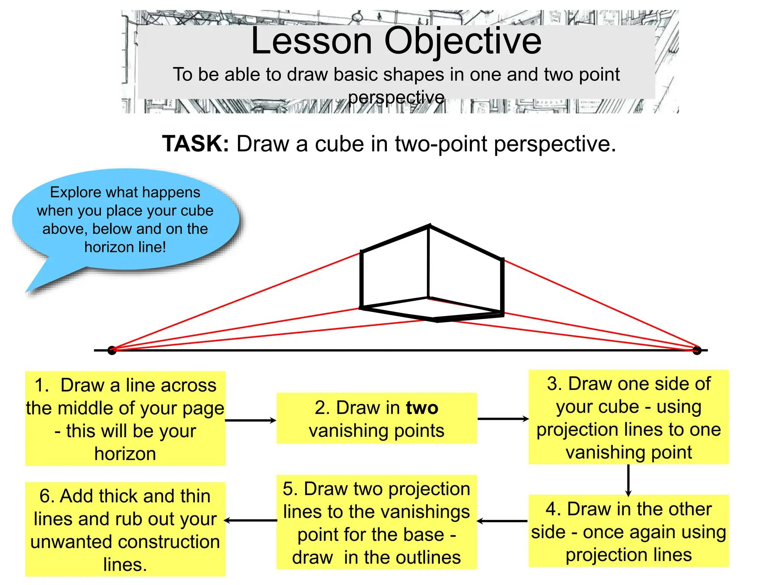
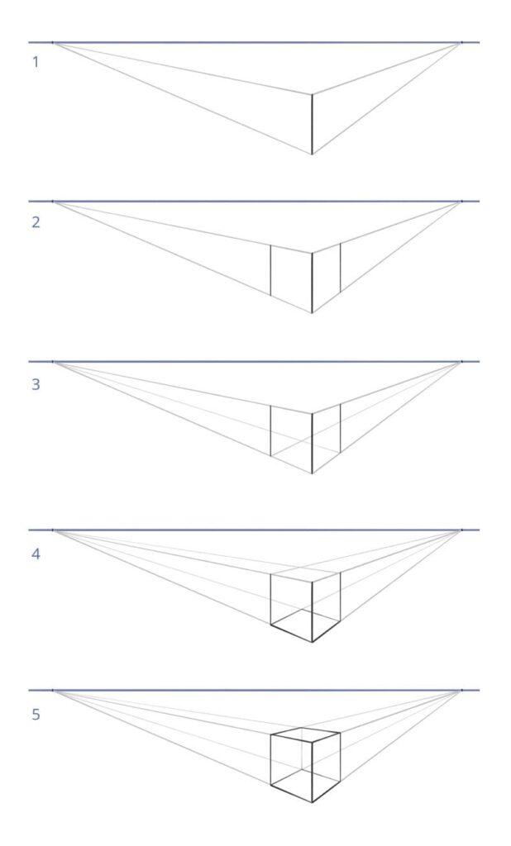
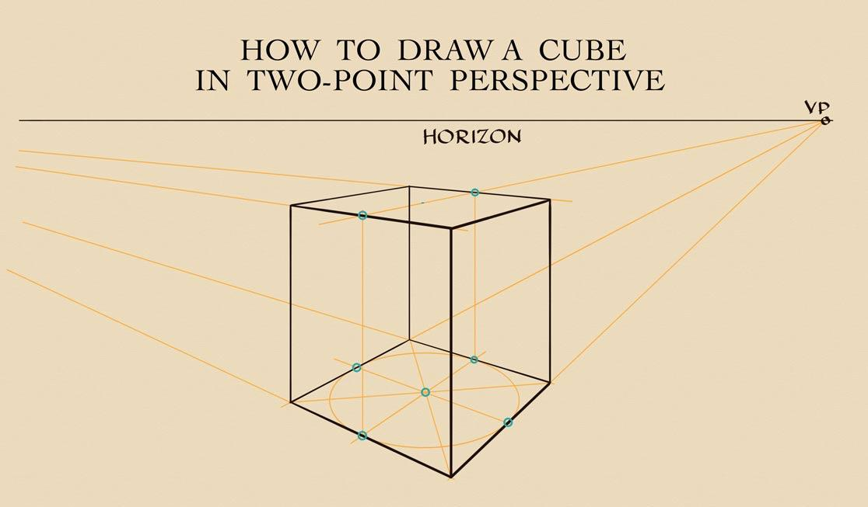

Properties
# Source: AI Source: Provided by: [Data Path: Persons Table -> ID Column: 1, Name_En Column: Motasem Essam] -> From: [ChatGPT] on [7/25/2026]
1. Two Principal Vanishing Points
$$\boxed{N=2}$$
where $N$represents the number of principal vanishing points.

2. Both Vanishing Points Lie on the Horizon
$$\boxed{V_{L},V_{R}∈HL}$$

3. Two Horizontal Directions Converge
One family of parallel lines converges toward $V_{L}$, while another converges toward $V_{R}$.

4. Vertical Lines Can Remain Parallel
In the standard two-point perspective arrangement:
$$\boxed{\text{Vertical lines remain vertical}}$$
provided the vertical direction is parallel to the picture plane.

5. Distant Parts Appear Smaller
As distance from the viewer increases:
$$\boxed{\text{Apparent size decreases}}$$

6. Parallelism Is Not Generally Preserved
Horizontal parallel lines can appear to converge.
For example:
$$L_{1}∥L_{2}$$
in 3D, but:
$$L_{1}^{'}∦L_{2}^{'}$$
in the perspective image.

7. Depth Is Represented Naturally
The two vanishing points provide a strong visual representation of spatial depth.

Two-Point vs One-Point Perspective
# Source: AI Source: Provided by: [Data Path: Persons Table -> ID Column: 1, Name_En Column: Motasem Essam] -> From: [ChatGPT] on [7/25/2026]
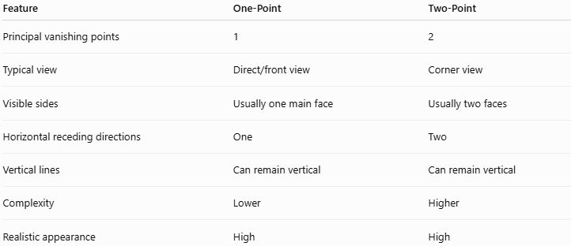
Feature | One-Point | Two-Point
Principal vanishing points | 1 | 2
Typical view | Direct/front view | Corner view
Visible sides | Usually one main face | Usually two faces
Horizontal receding directions | One | Two
Vertical lines | Can remain vertical | Can remain vertical
Complexity | Lower | Higher
Realistic appearance | High | High
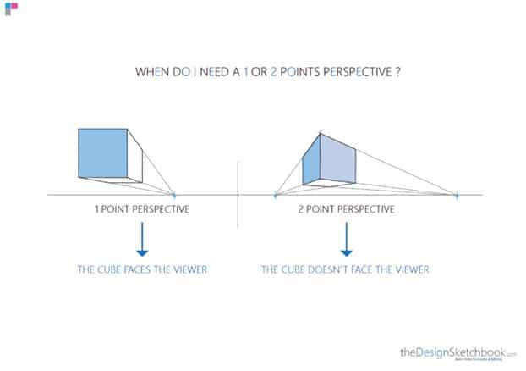
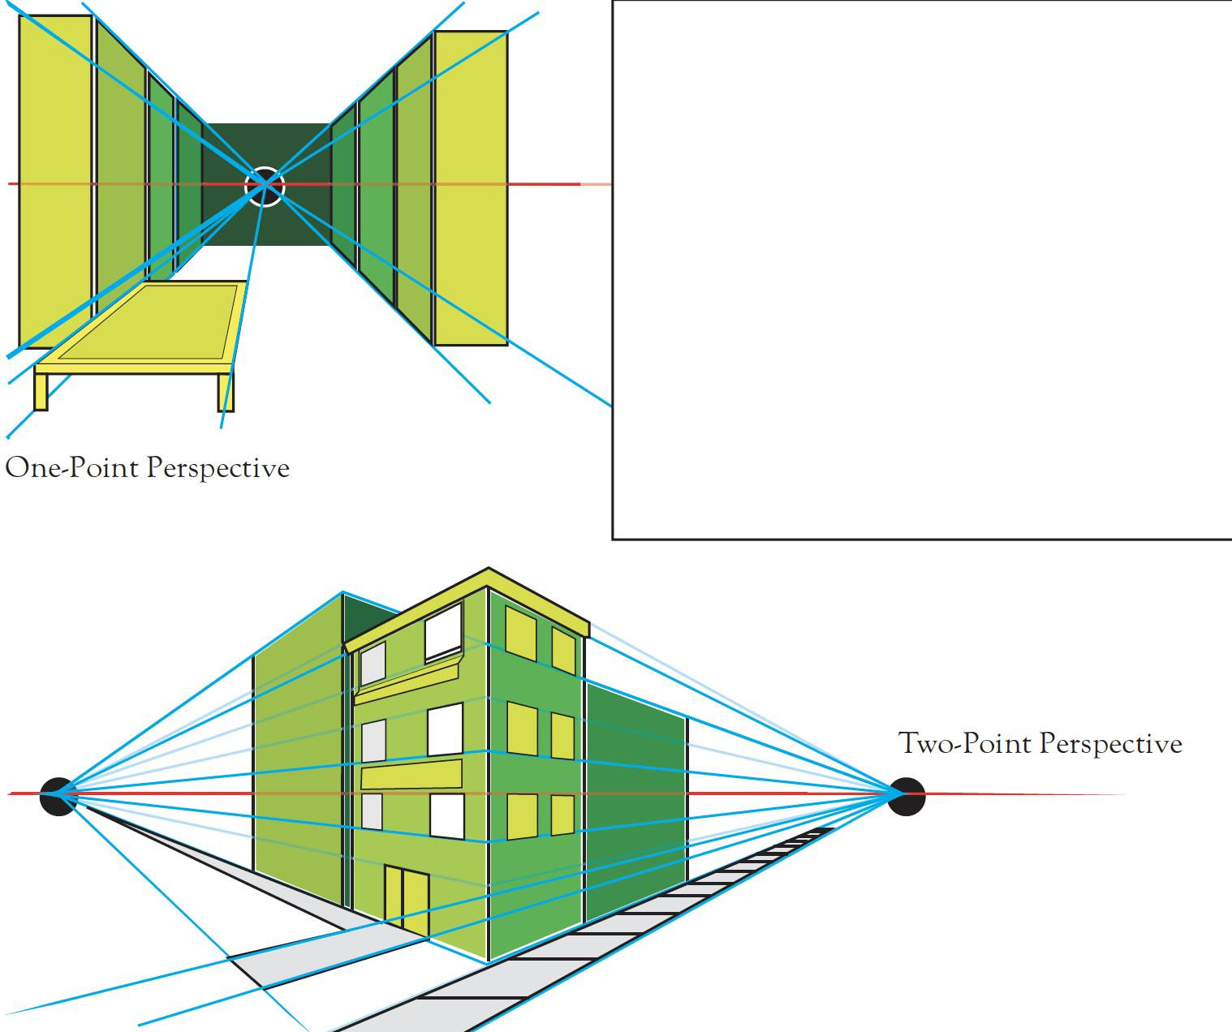
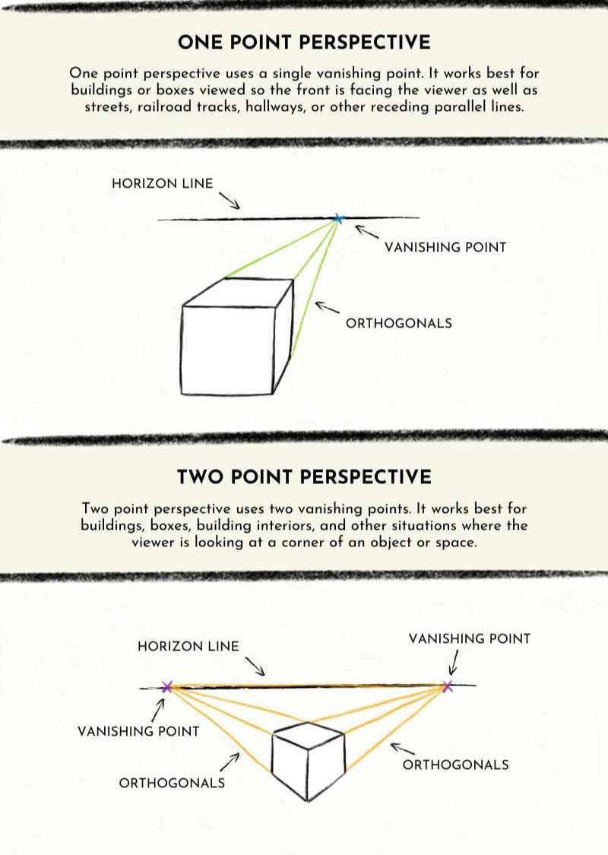
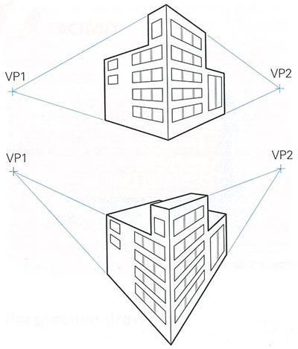
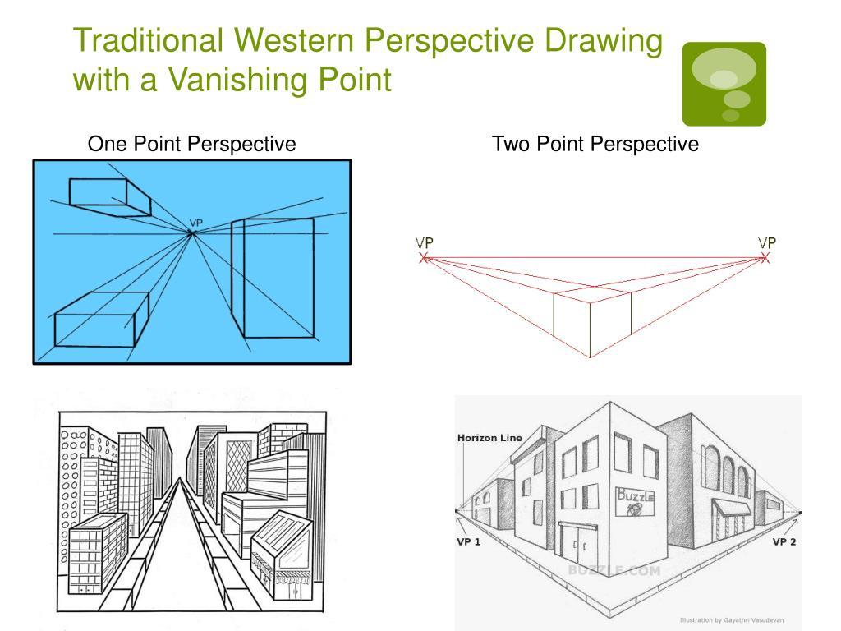

Two-Point vs Three-Point Perspective
# Source: AI Source: Provided by: [Data Path: Persons Table -> ID Column: 1, Name_En Column: Motasem Essam] -> From: [ChatGPT] on [7/25/2026]
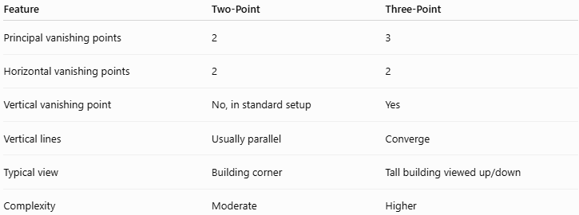
Feature | Two-Point | Three-Point
Principal vanishing points | 2 | 3
Horizontal vanishing points | 2 | 2
Vertical vanishing point | No, in standard setup | Yes
Vertical lines | Usually parallel | Converge
Typical view | Building corner | Tall building viewed up/down
Complexity | Moderate | Higher

Two-Point vs Parallel Projection
# Source: AI Source: Provided by: [Data Path: Persons Table -> ID Column: 1, Name_En Column: Motasem Essam] -> From: [ChatGPT] on [7/25/2026]
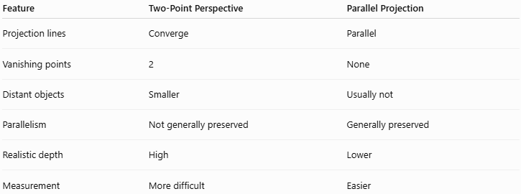
Feature | Two-Point Perspective | Parallel Projection
Projection lines | Converge | Parallel
Vanishing points | 2 | None
Distant objects | Smaller | Usually not
Parallelism | Not generally preserved | Generally preserved
Realistic depth | High | Lower
Measurement | More difficult | Easier

Two-Point vs Cavalier Projection
# Source: AI Source: Provided by: [Data Path: Persons Table -> ID Column: 1, Name_En Column: Motasem Essam] -> From: [ChatGPT] on [7/25/2026]
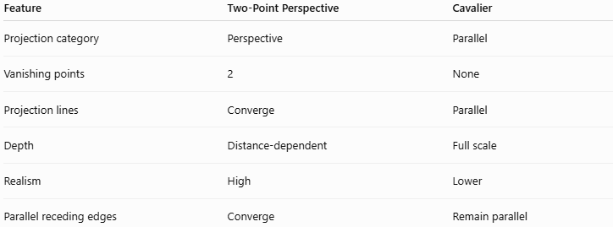
Feature | Two-Point Perspective | Cavalier
Projection category | Perspective | Parallel
Vanishing points | 2 | None
Projection lines | Converge | Parallel
Depth | Distance-dependent | Full scale
Realism | High | Lower
Parallel receding edges | Converge | Remain parallel

Two-Point vs Cabinet Projection
# Source: AI Source: Provided by: [Data Path: Persons Table -> ID Column: 1, Name_En Column: Motasem Essam] -> From: [ChatGPT] on [7/25/2026]
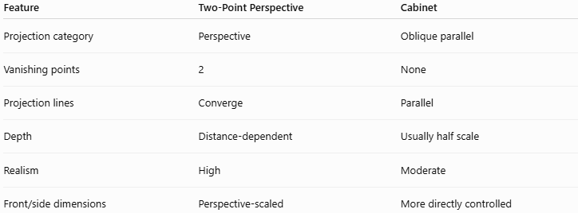
Feature | Two-Point Perspective | Cabinet
Projection category | Perspective | Oblique parallel
Vanishing points | 2 | None
Projection lines | Converge | Parallel
Depth | Distance-dependent | Usually half scale
Realism | High | Moderate
Front/side dimensions | Perspective-scaled | More directly controlled

Applications
# Source: AI Source: Provided by: [Data Path: Persons Table -> ID Column: 1, Name_En Column: Motasem Essam] -> From: [ChatGPT] on [7/25/2026]
Two-point perspective is commonly used in:
- Architecture
- Architectural visualization
- Interior design
- Engineering visualization
- Product design
- Urban planning
- Photography
- Film
- Animation
- Video games
- Computer graphics
- 3D modeling
- Technical illustration

Advantages
# Source: AI Source: Provided by: [Data Path: Persons Table -> ID Column: 1, Name_En Column: Motasem Essam] -> From: [ChatGPT] on [7/25/2026]
- Provides a realistic representation of 3D objects.
- Shows two sides of an object simultaneously.
- Creates strong depth perception.
- Well suited to buildings viewed from corners.
- More flexible than one-point perspective for many architectural scenes.
- Closely resembles real-world visual perception.
- Useful for architectural visualization.

Limitations
# Source: AI Source: Provided by: [Data Path: Persons Table -> ID Column: 1, Name_En Column: Motasem Essam] -> From: [ChatGPT] on [7/25/2026]
- More complicated than one-point perspective.
- True dimensions are not directly preserved.
- Parallel lines may appear to converge.
- Requires two vanishing points.
- Can produce excessive distortion if the vanishing points are positioned poorly.
- Less suitable than parallel projection for directly reading dimensions.

Special Cases

Vanishing Points Very Far Apart
# Source: AI Source: Provided by: [Data Path: Persons Table -> ID Column: 1, Name_En Column: Motasem Essam] -> From: [ChatGPT] on [7/25/2026]
If:
$$V_{L}$$
and:
$$V_{R}$$
are very far from the object, perspective distortion becomes weaker.
The drawing can begin to resemble a parallel projection.

Symmetrical View
# Source: AI Source: Provided by: [Data Path: Persons Table -> ID Column: 1, Name_En Column: Motasem Essam] -> From: [ChatGPT] on [7/25/2026]
If the object is positioned symmetrically relative to the viewer, the two vanishing points can be placed symmetrically around the center of the image.

Transition to One-Point Perspective
# Source: AI Source: Provided by: [Data Path: Persons Table -> ID Column: 1, Name_En Column: Motasem Essam] -> From: [ChatGPT] on [7/25/2026]
If one principal direction becomes parallel to the picture plane, its vanishing point moves effectively to infinity.
The representation can then approach a one-point perspective arrangement.

Relationship to Perspective Projection
# Source: AI Source: Provided by: [Data Path: Persons Table -> ID Column: 1, Name_En Column: Motasem Essam] -> From: [ChatGPT] on [7/25/2026]
The hierarchy is:
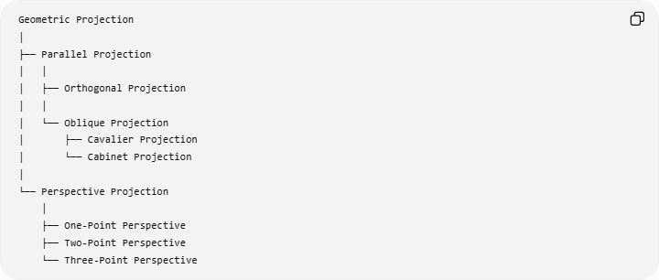
Geometric Projection
│
├── Parallel Projection
│ │
│ ├── Orthogonal Projection
│ │
│ └── Oblique Projection
│ ├── Cavalier Projection
│ └── Cabinet Projection
│
└── Perspective Projection
│
├── One-Point Perspective
├── Two-Point Perspective
└── Three-Point Perspective
Therefore:
$$\boxed{\text{Two-Point Perspective}⊂\text{Perspective Projection}}$$

Key Points
# Source: AI Source: Provided by: [Data Path: Persons Table -> ID Column: 1, Name_En Column: Motasem Essam] -> From: [ChatGPT] on [7/25/2026]
- Two-Point Perspective is a type of perspective projection.
- It uses two principal vanishing points.
- The vanishing points lie on the same horizon line:
$$\boxed{V_{L},V_{R}∈HL}$$
- One family of horizontal lines converges toward $V_{L}$.
- Another family converges toward $V_{R}$.
- Vertical lines can remain vertical in the standard arrangement.
- It is commonly used when viewing an object from a corner.
- Buildings, boxes, and urban scenes are common examples.
- It provides stronger and more flexible depth representation than one-point perspective.

Conclusion
# Source: AI Source: Provided by: [Data Path: Persons Table -> ID Column: 1, Name_En Column: Motasem Essam] -> From: [ChatGPT] on [7/25/2026]
Two-Point Perspective represents a three-dimensional object using two principal vanishing points. The two horizontal directions of the object recede toward different points on the horizon line, while vertical lines can remain parallel in the standard configuration. This makes two-point perspective especially useful for representing buildings, boxes, and other objects viewed from a corner.
$$\boxed{\text{Two-Point Perspective}=\text{Two Vanishing Points}+\text{Perspective Depth}}$$

